**OpenPyFlySim**



**A Flight Simulator written in Python and OpenGL**

*Adrian Draber*

*22018721 Woodhouse College*Table of Contents

1 Analysis 2

1.1 Introduction 2

1.2 Existing products 3

YSFLIGHT 3

FlightGear 7

1.3 End user research 7

1.4 Objectives 9

1.5 Modules 10

1.6 Implementation Research 12

Transformations 12

Culling 14

Camera System 15

1.7 Prototyping 17

Prototype 1 17

Prototype 2 18

Prototype 3 19

2 Documented Design 19

3 Implementation 19

4 Technical Solution 19

5 Testing 19

6 Evaluation 19

7 References 19

# Analysis

## Introduction

Flight simulators are a genre of program where the user assumes control over an aircraft, such as a plane. Usually, they strive for realism, particularly because they are used to train pilots and other jobs involved in the air industry such as air traffic controllers. From a technical perspective, they present an interesting challenge due to the requirement to render three-dimensional environments and replicate the physics of real aircraft.

In this project, I aim to build a virtual flight simulator from the ground up, focusing on achieving accurate rendering of three-dimensional environments as well as replicating a very basic system of aircraft controls. The project should primarily aim to demonstrate the ability to use mathematics to project environments onto a two-dimensional screen and do so in an effective and optimised manner. Additionally, the program should also function as a learning tool for – primarily amateur or recreational – pilots, and thus possess systems such as measuring the G-force on the cockpit, or the ability to take off/land. These are important as making mistakes while flying a real plane could be potentially dangerous, so it could assist in helping amateurs recognise dangerous manoeuvres.

## Existing products

The following is an analysis of some existing flight simulators:

### YSFLIGHT

YSFLIGHT[1] is a Flight Simulator written in C++ using OpenGL by Soji Yamakawa, with its first release in 1999, and it has received regular updates ever since.

According to Yamakawa, the program was written for the purposes of *“(1) writing my own flight simulator, and (2) writing a software used by hundreds of thousands of people over the world. I am always so happy to receive encouraging emails about YSFLIGHT.”*. Initially created as a school project, it was turned into software to help people learn to understand aircraft physics and mechanics: *“Microsoft Flight Simulator is a great piece of work, but I also believe it is nice to have a flight simulator that everyone can casually play during the lunch break. That has been the concept of YSFLIGHT. But, I put many elements that I learned from my flight training in YSFLIGHT. I do use YSFLIGHT for practicing IFR approaches in a Cessna for myself (of course I'm not logging time for it though.) I hope YSFLIGHT serves you well for the future!”.[2]*

Booting up YFLIGHT, we are treated to this menu where we choose a starting location and model of plane, among other factors:

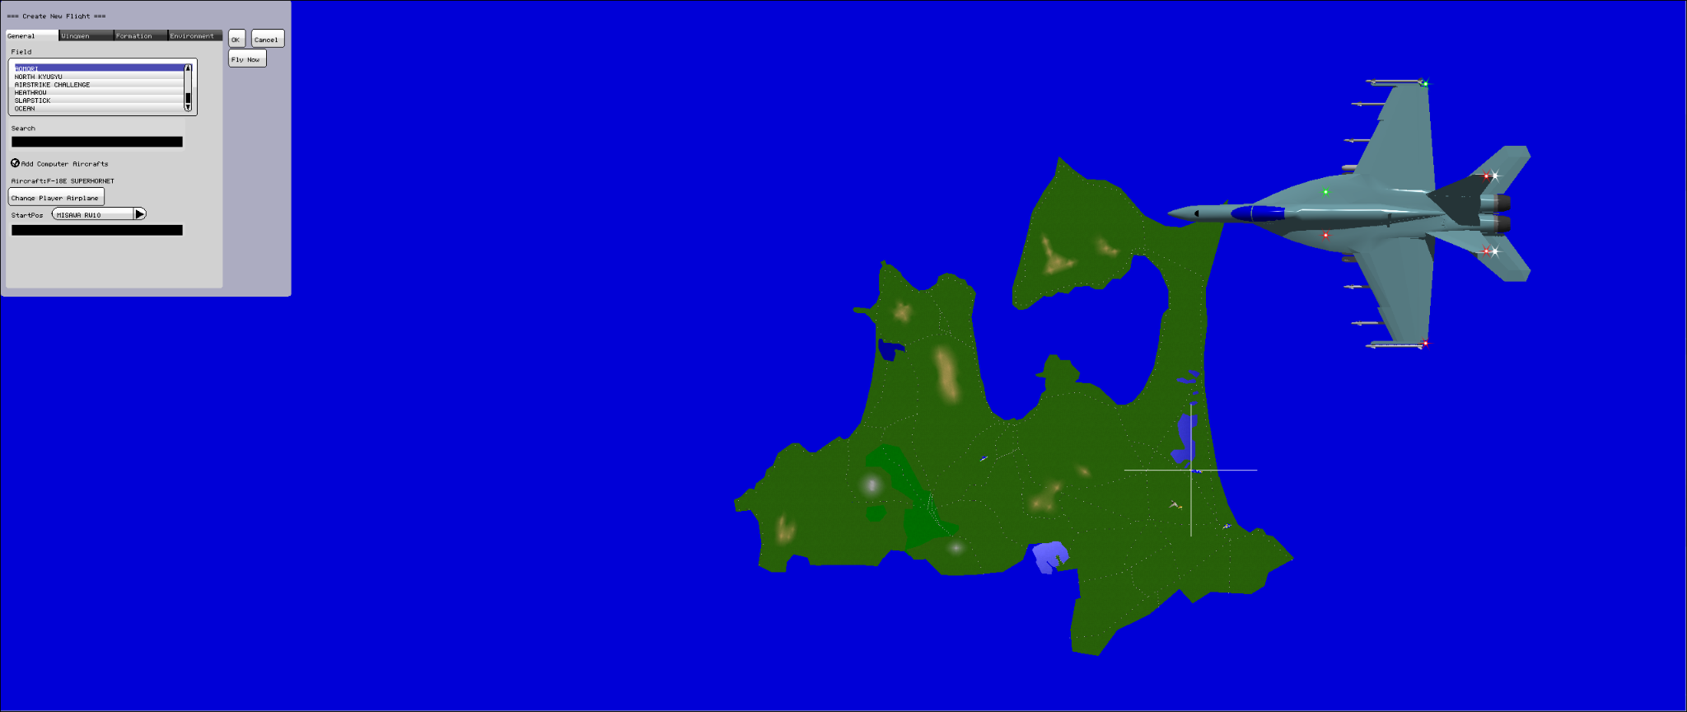

*Figure 1: The screen before starting a flight.*

YFLIGHT is primarily designed for joystick control; however, the mouse and keyboard can be used to simulate joystick input. Upon entering the cockpit, several features of the control scheme stand out:

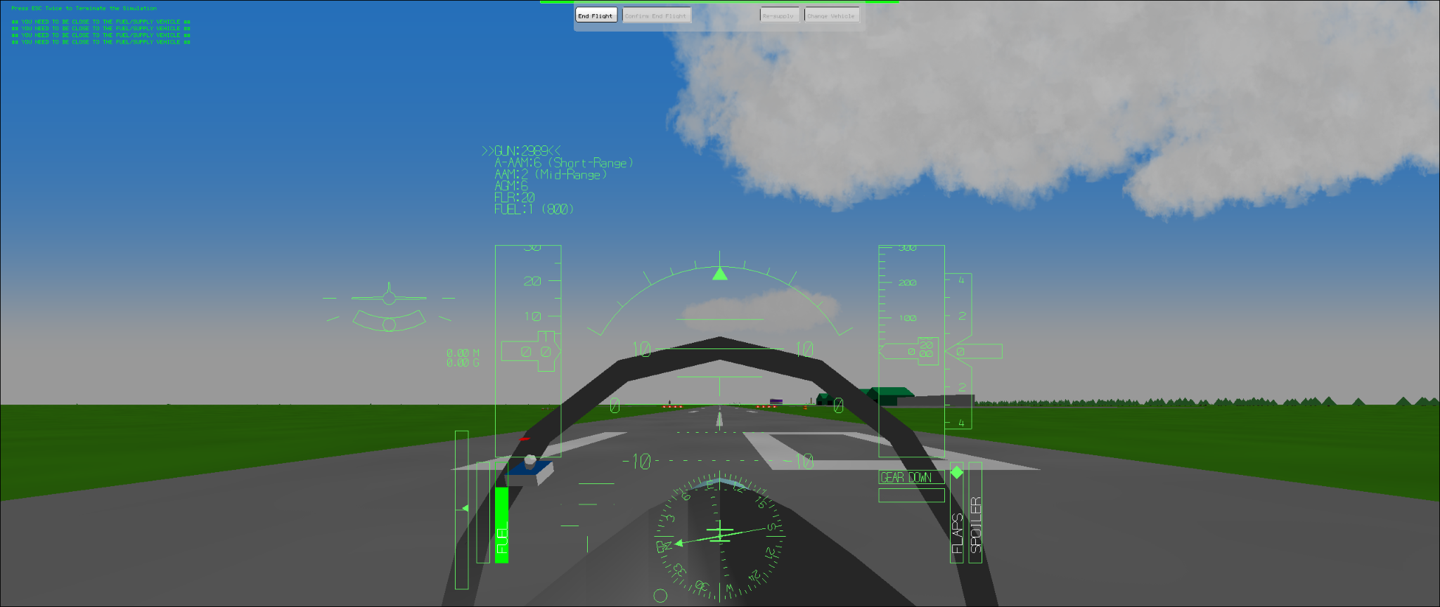

*Figure 2: After starting; plane is on the runway.*

* There is a virtual joystick on screen, seen on the left of the cockpit in the image. This allows the pilot to always see the status of the joystick, which is useful for mouse controls.
* There are physical flaps and spoiler indicators (bottom right of the UI). These are the controls used on real places and are responsible for turning motions. Having physical bars showing the orientation of each helps with visibility of the controls substantially.
* There is a virtual plane on the left side of the UI, showing its orientation relative to the ground - this is useful because YS Flight primarily employs a camera perspective from inside the cockpit.
* However, one drawback is that controls aren’t easily explained, and you can’t access the control menuy from inside the simulator.

*Figure 3: The screen while in flight*

The simulator also contains several pre-built scenarios, such as trying to land a plane at a recreation of London Heathrow. After playing around with the flight controls for an hour, these are some interesting features I noticed:

* As noted in the Introduction, it is important for flight simulators to accurately convey dangerous manoeuvres to teach aspiring pilots in an environment where no risks are posed regarding their safety. YS Flight achieves this by colouring the entire screen red or black when a high G-force is reached, which functions as an easy-to-read indicator of pilot danger.
* Sideways motion of the joystick controls roll (sideways rotation of the plane) while up/down motion controls pitch (up-down rotation). Yaw, the rotation that corresponds to the direction on the map the plane is facing, is controlled with the ZXC keys (which physically control the “rudder” at the back of the plane).
* Pressing the “M” key reveals a second camera view, behind the cockpit. This is useful in the case of YS Flight since it can be used as a military dogfight simulator in addition to its main use as an amateur flight sim.
* In addition to visual indicators, various bleeps and other noises are used to communicate information to the pilot. These serve as easily recognisable warnings that recommend pilots to look at their gauges - for instance, they might indicate that fuel is not flowing to the engine during a turning manoeuvre due to the forces involved.

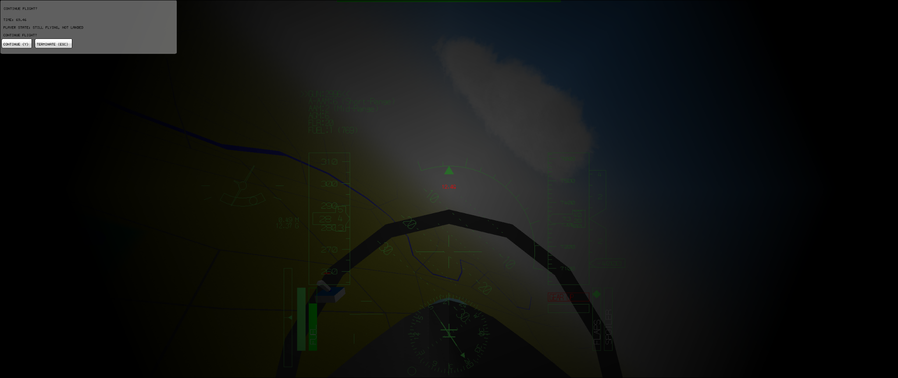

*Figure 4: The screen turns black as I hit 12.4G during a manoeuvre. In real life, this amount of force would kill the pilot.*

### FlightGear

## End user research

As previously identified, the target audience for such a program would primarily be hobbyist/amateur pilots, particularly those who can’t practise by flying a real plane. In order to understand the demands of this community, which will be used to inform my objectives, I contacted various flight enthusiast communities and asked them what they enjoyed about their particular flight simulator. I was able to get 12 responses, which I categorised into five broad categories:

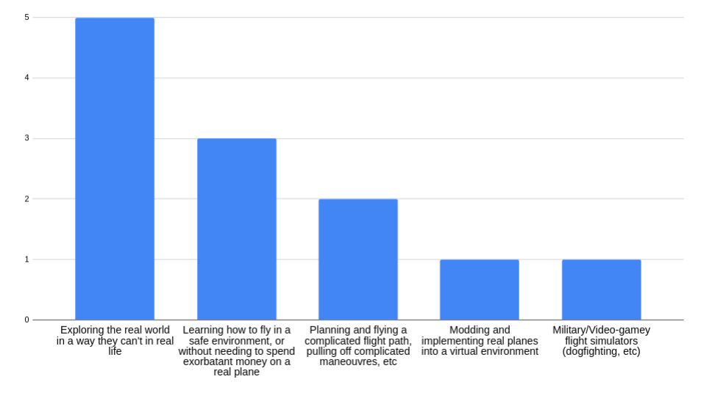

*Figure 5: The 5 categories of the 12 responses I got by asking people what they enjoyed about <x> flight simulator. Respondents are kept anonymous.*

It is important to emphasise that many different subcommunities exist within the “flight simulator” genre. Some people prefer realistic, expensive flight simulators, which allows them to feel like a pilot and explore the real world. As seen in the survey, this was the most representative group. This makes sense as I collected part of this data in a community dedicated to Microsoft Flight Simulator. There is also a large community however dedicated to modding these simulators and implementing their own hyper realistic plane models. There also exist many video games based around aeroplanes which mostly use air combat and dogfighting as a source of appeal. These include War Thunder and Ace Combat.

From my survey however, it appears that exploration and the idea that the entire world is at one’s fingertips is one of the most prevalent reasons for picking up flight simulation as a hobby, particularly as a hobby. For instance, one user told me:

*“It lets me explore different places without actually going there. It’s also got good graphics and attention to detail which makes it a chill way to virtually travel and take in the sights”.*

Taking this into account, since this program is meant to follow a similar philosophy as Soji Yamakawa’s YSFLIGHT, I will focus primarily on the first two appeals - the ability to virtually explore the world, and the ability to be a pilot without heavy investment in flight school and aircraft. It also appears that customisation is also an interest of the community, so I will add the ability to import custom maps. However, some features - such as air combat or a fully detailed and realistic map of the real world - will need to be discarded as they are far beyond the scope of this project.

## Objectives

The investigation asks for the following requirements to be satisfied:

1. Load in a world from a map. This can be a real map of a real environment, or fictional.
   * + 1. Use a .bmp file or similar to store a heightmap of some terrain. The brightness values on this heightmap will correspond to the actual in-program height of the terrain at that location.
       2. Allow for import of custom maps.
2. Render the terrain on-screen according to the location of the player’s camera, and the direction in which it is pointing.
   * + 1. Orient the camera in the correct direction, and update its position according to velocity.
       2. At the start of the program, define all vertices in the world map, complete with colour, elevation, etc
       3. Determine the vertices within the player’s current viewport and their distance. Then, only render the vertices within the render distance.
       4. Define a water level. Any vertices below this level will be underwater, so draw a water line.
       5. Use back-face culling technique so that only triangles facing the camera are being rendered
       6. Draw 2D triangles between the on-screen vertices.
       7. Update this process for every frame.
3. Render other props
   * + 1. Render the plane model.
       2. Render terrain details - trees, etc
4. Allow player input, such as the ability to shift the rudder and ailerons in order to perform turning manoeuvres.
   * + 1. Update velocity and angles as determined by input.
5. Make use of JIT to speed up the program’s performance.
6. Implement taking off and landing as mechanisms.
7. Implement a title screen and UI (similar to the one in YSFlight) to allow control of initial conditions.

## Modules

We will make use of the following Python modules:

* OpenGL[3] – OpenGL is a graphics API for rendering vector graphics. This will be the primary method we will use to draw what is going on screen. Additionally, to extend OpenGL’s functionality, we will utilise the OpenGL Utility Library (GLU) and OpenGL Utility Toolkit (GLUT)[4]. In Python, this will require installation of the pyOpenGL and pyOpenGL-accelerate modules, as well as of a GLUT library such as freeGLUT to the PC/Virtual Environment. The justification for choosing this library is its ease of use and support with most PC systems, which is what led to it being considered the “standard” library for amateur graphics projects.
* NumPy[5] – This is a library that extends Python’s mathematical features. For instance, it allows us to use arrays, whereas base python only allows for linked lists – this is useful because arrays are significantly more efficient than linked lists. Given the nature of graphics needing to be updated many times per second, it is crucial that we write an efficient program.
* PyGame[6] – We will use PyGame in order to handle both our display and input of controls. While PyGame provides many other uses, such as drawing content directly onto the screen, this will be handled by OpenGL in our application. Additionally, the pygame.joystick module of pygame allows for reading joystick controls, such as from a gamepad, which is considered the “default” controller for flight sims and is preferred over mouse and keyboard (as seen in the “existing products” section).
* Numba[7] - Numba is a Just-In-Time compiler for Python - while a script is being interpreted, it will compile any function given the @njit decorator, allowing it to run faster. The downside is that a compiled function cannot make use of foreign modules or refer to other functions in the program. Despite this, including this module to compile some of our python functions may lead to great improvements in performance.

## Implementation Research

Based on my research of existing flight simulators, I was able to create a list of objectives. In order to check their feasibility, I created a series of prototypes regarding their implementation. I first performed research into how many of my intended features will be implemented.

### Transformations

OpenGL functions primarily on the principle of vertices, which have lines, triangles and squares (“quads”) drawn between them. We can move these vertices via the use of matrix transformations:

*Figure 6: The transformation matrix in OpenGL.[8]*

Here, we have a 3x3 matrix representing the points themselves, as well as a fourth row and column that allows us to perform translations. Some examples of specific uses to achieve certain matrix transformations:

*Figure 7: Example of a translation; scaling; and rotation around the x axis.[8]*

One thing to note is that matrices are non-commutative. This means that the order of operations does matter. In particular, matrices are always modified by operations behind them. The order of operations of a matrix is hence often “reversed”. We can also merge matrices into a single transformation:

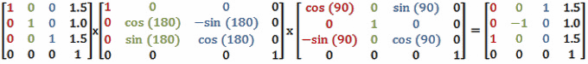

*Figure 8: If performed separately, we’d consider the rotation around y to be performed first, followed by the rotation around x and finally the translation. Here we can also simplify this to a single transformation.[8]*

While OpenGL does not require us to manually input matrices, it does still follow the rules of matrix mathematics – for instance, in OpenGL, transformations will appear to be performed in the “reversed” order compared to their definition in the code. Additionally, since matrix transforms are applied to all vertices, we need to make use of a stack so that only specified sets of vertices are available at any time to be transformed – else, every time we perform any sort of transform, everything in the world is transformed.

### Culling

*Figure 9: An image from one of my prototypes. No culling algorithm is being used; we can see that the magenta face clips through the cube, since it is drawn after the cyan face (but before the grey and yellow faces).*

The culling method used by OpenGL involves discarding faces that are “facing away” from the viewport, in a process called Face Culling. This is achieved via winding order. When triangles are drawn, the vertices are defined in an order. The order of the vertices is used to define whether a triangle’s vertices are defined as counterclockwise or clockwise. By default, any triangle with counterclockwise vertices is considered to be seen from the front, while triangles with clockwise vertices are seen from the back.

*Figure 10: Two triangles, drawn with clockwise and counterclockwise vertices. OpenGL considers the clockwise triangle to be seen from the back and it would be culled.[9]*

OpenGL also allows us to change whether front or back faces are culled. For instance, we can set it so faces considered to be front facing are culled instead.

*Figure 10: A cube with all front-facing faces culled.*

### Camera System

OpenGL has an inbuilt gluLookAt function which takes the current position, a “look at position” and an “up” position and orients the camera to match all three.

[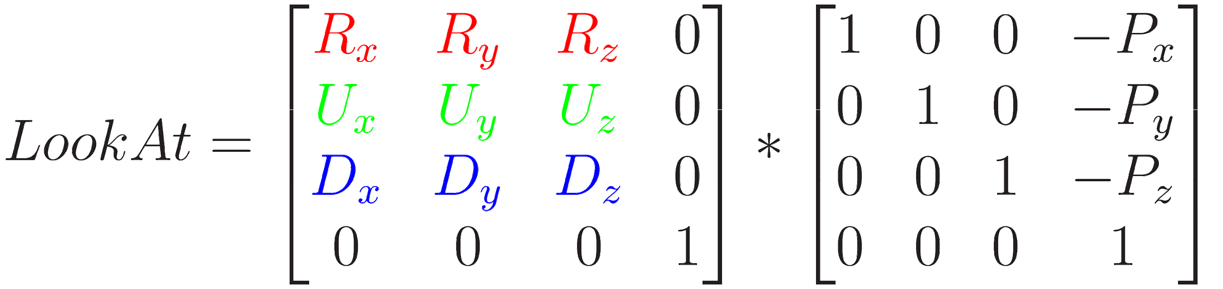](http://www.sciweavers.org/tex2img.php?bc=Transparent&fc=Black&im=jpg&fs=100&ff=modern&edit=0&eq=LookAt%20%3D%20%5Cbegin%7Bbmatrix%7D%20%5Ccolor%7Bred%7D%7BR_x%7D%20%26%20%5Ccolor%7Bred%7D%7BR_y%7D%20%26%20%5Ccolor%7Bred%7D%7BR_z%7D%20%26%200%20%5C%5C%20%5Ccolor%7Bgreen%7D%7BU_x%7D%20%26%20%5Ccolor%7Bgreen%7D%7BU_y%7D%20%26%20%5Ccolor%7Bgreen%7D%7BU_z%7D%20%26%200%20%5C%5C%20%5Ccolor%7Bblue%7D%7BD_x%7D%20%26%20%5Ccolor%7Bblue%7D%7BD_y%7D%20%26%20%5Ccolor%7Bblue%7D%7BD_z%7D%20%26%200%20%5C%5C%200%20%26%200%20%26%200%20%20%26%201%20%5Cend%7Bbmatrix%7D%20*%20%5Cbegin%7Bbmatrix%7D%201%20%26%200%20%26%200%20%26%20-%5Ccolor%7Bpurple%7D%7BP_x%7D%20%5C%5C%200%20%26%201%20%26%200%20%26%20-%5Ccolor%7Bpurple%7D%7BP_y%7D%20%5C%5C%200%20%26%200%20%26%201%20%26%20-%5Ccolor%7Bpurple%7D%7BP_z%7D%20%5C%5C%200%20%26%200%20%26%200%20%20%26%201%20%5Cend%7Bbmatrix%7D#0)

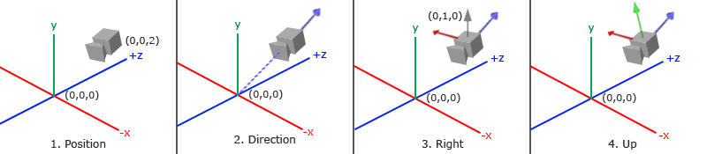

*Figures 11 and 12: How the gluLookAt function works. In the top matrix R is the “right” vector, U is the “up” vector, D is the “direction” vector and P is the camera’s position. The bottom mage shows a visual representation of these four vectors on the camera.[10]*

While this simplifies the amount of maths needed substantially, we still need to start by defining the three Euler angles. These look as follows:

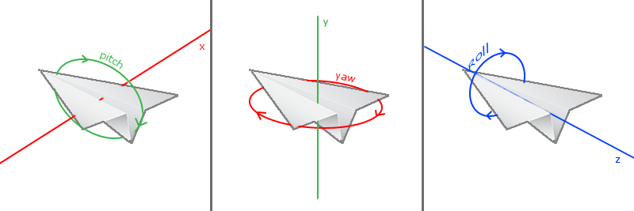

*Figure 12: The three Euler angles.[10]*

These angles can then be updated by the program, in a way corresponding to real plane controls. In order to move the camera, we must consider the x and y components of our rotations. For pitch and roll, this looks as follows:

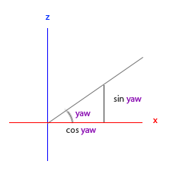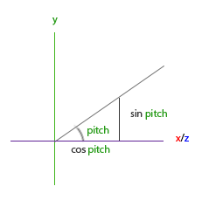

*Figure 13: Determining the x and y components of yaw and pitch.[10]*

Using this, we can construct a “front” coordinate that is 1 unit away from the camera, which represents our direction vector. By taking the cross product of direction and up relative to the world (ie. (0,1,0)) we can get a right vector. The cross product is simply defined as the vector that is perpendicular to both vectors, and thus in the plane normal to the plane containing them. Taking the cross product of right and direction, we get our relative up vector, which is the third vector we need to rotate our camera.

Once all three are implemented, we will have a working camera system that can look at all 360 degrees around itself.

## Prototyping

### Prototype 1

The goal of Prototype 1 was to familiarise myself with OpenGL. I set out to achieve a basic task - rendering a 3d wireframe cube. After installing all the required modules, I followed an online tutorial[11] to learn the basics of pyOpenGl, and copied the code while taking notes and writing comments to better understand it. While I had some trouble getting the screen to work, which was done through PyGame, the code itself was simple to understand for me and I was able to run it effortlessly.

The wire cube works by defining 8 vertices in a tuple, and then creating 12 edges that contain two numbers indexing the vertices.

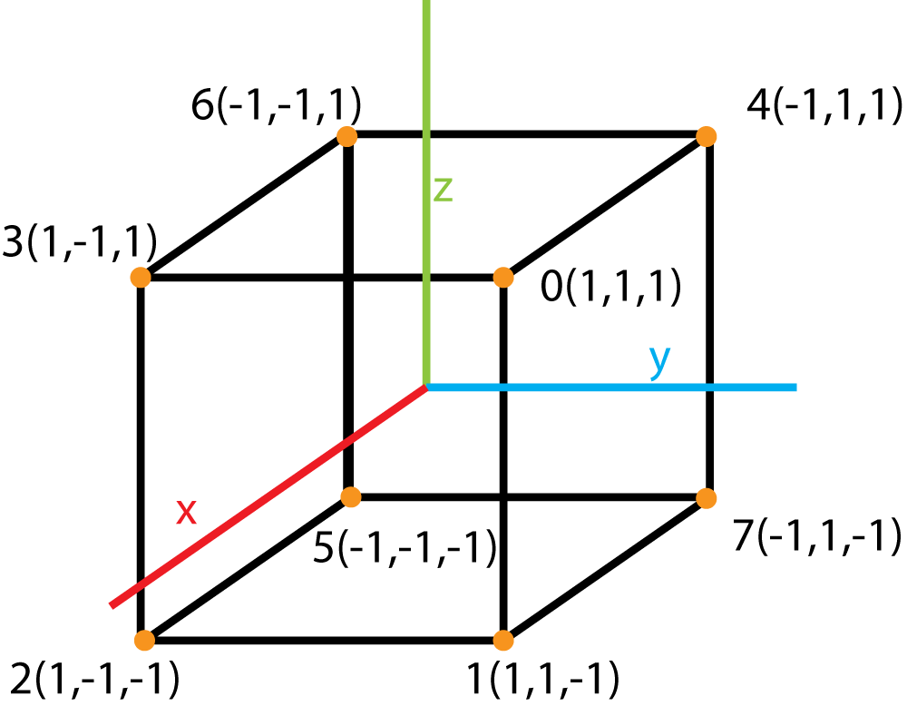

*Figure 14: A diagram of the points constituting the cube.[11]*



*Figure 15: The definition of the vertices and edges in the code.*

As the program is run, a subroutine is constantly executed which updates the cube and draws the lines via the GL_Lines parameter.

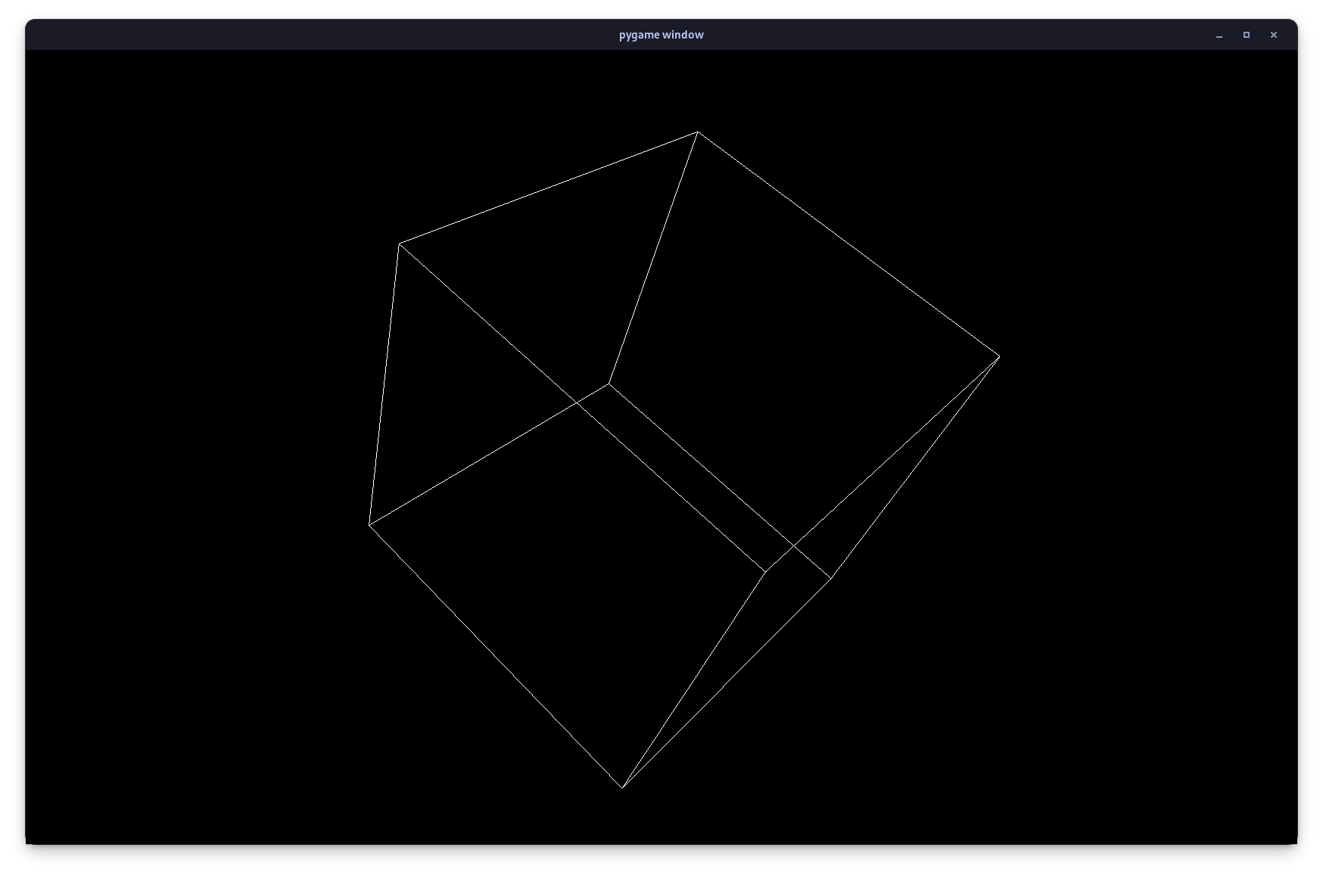

*Figure 16: Prototype 1.*

### Prototype 2

In order to challenge myself, and put my knowledge of culling and transformations to use, I wanted to expand upon Prototype 1 with my own code to create a cube with 6 coloured faces that can be rotated by the user.

Similar to how the edges for the wire cube were defined as indexes of a tuple of vertices, a tuple of indexes was used to make 6 faces. A separate tuple then contained the colours of each face.

I had to make sure that each face had its vertices defined in the correct order as per the culling system, which uses counterclockwise-defined faces as front faces. This took a substantial amount of trial and error before I got it to work right.

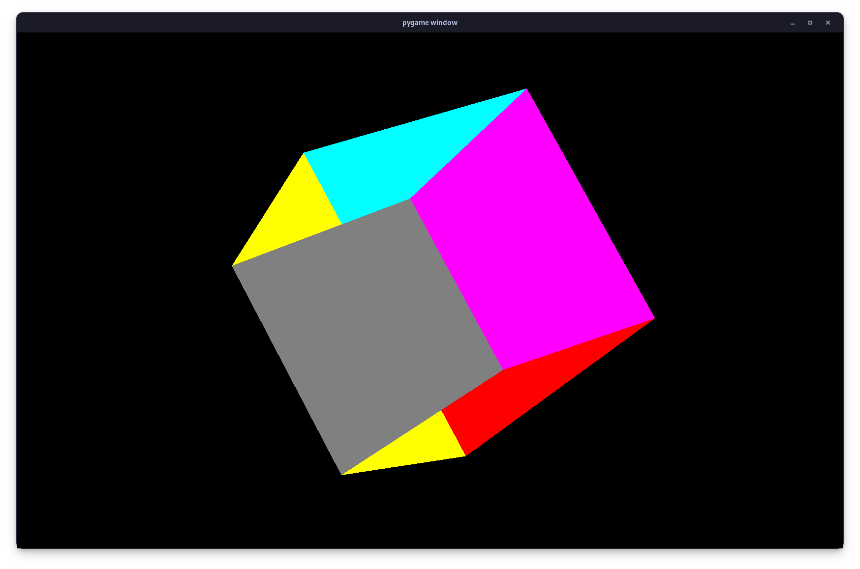

*Figure 17: Improperly defined faces, causing them to clip through each other.*

Adding user controls was less difficult. Pygame has an inbuilt pg.key.get_pressed() method, which can be referenced to check what keys have been pressed. I chose to use the QAWSED keys to control the three axes of rotation.

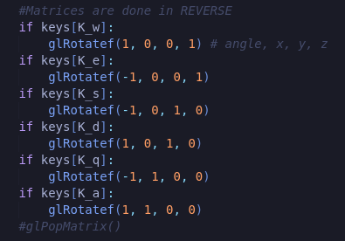

*Figure 18: The code behind the rotation of the cube.*

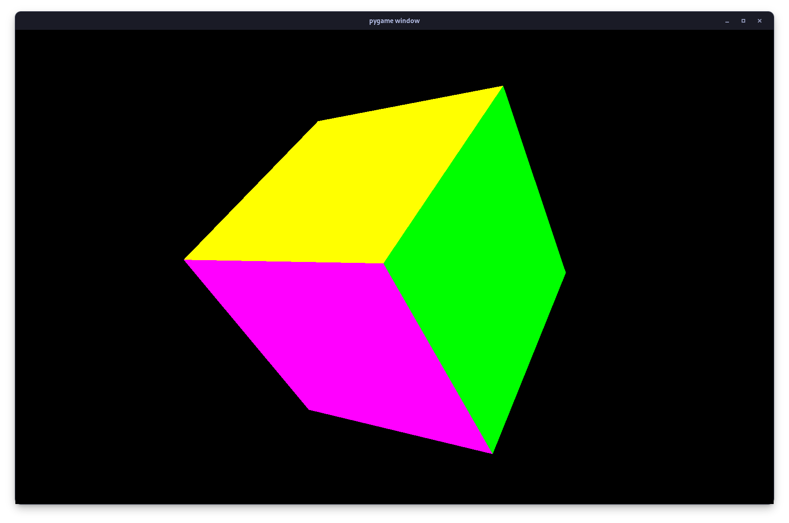

*Figure 19: Prototype 2.*

### Prototype 3

Using what I had learnt from the previous two prototypes, I decided to start from scratch and write a program that would generate a plane of triangles with random height. This would serve as a prototype for the ground terrain of the final product.

In order to draw the plane, I defined an x and y height. For every vertice in this plane, two triangles were drawn as so:

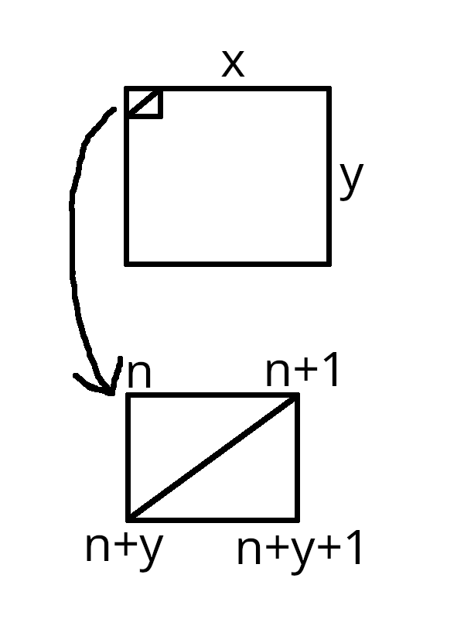

*Figure 20: A plane of 2xy triangles and how they are rendered. The values at each corner are then used to index an array of points with randomly generated y values.*

At the start of each instance, every single vertex was defined in a list, together with a randomly generated y value and colour.

One issue I encountered was the extremely poor performance. I dealt with this by fixing several bugs and replacing the linked list of vertices with a NumPy array.

Another issue was triangles seemingly generating across the entire grid:

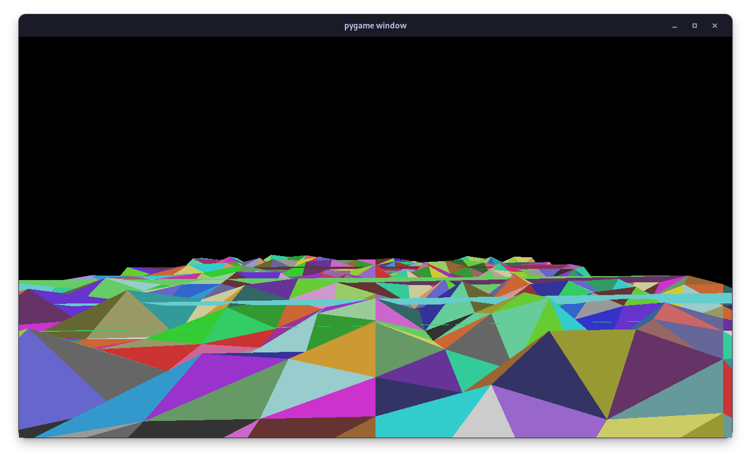

*Figure 21: Notice the triangles at the edge of the plane generating across the entire map.*

The fix for this turned out to be trivial when I revisited my diagrams of how the plane is generated. At the edge of every column of the plane, n+1 would be at x=0 on the next row down - on the other side of the entire plane. To prevent this from happening, I added this check in the code:



*Figure 22: Checks if the vertex is at the end of its respective column. If its location would mean drawing a triangle to the next row down, ignore it.*

I also used glTranslatef to add a basic WASD movement system, although the ability to turn the camera wasn’t yet implemented due to the greater complexity of the camera system. Using glutBitmapString, I also implemented an FPS counter so that I could keep track of the performance of my program.

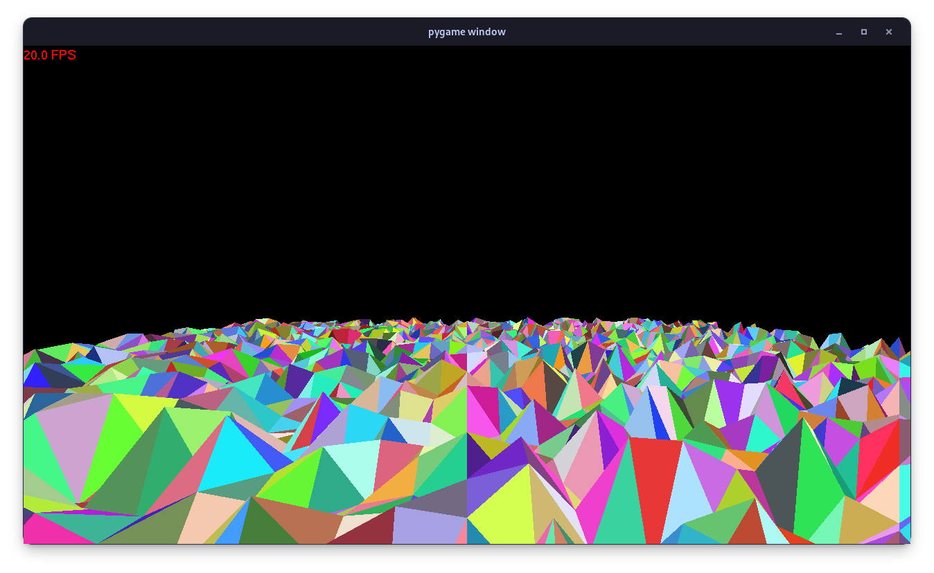

*Figure 23: Prototype 3. 5,000 triangles drawn at 20fps.*

# Documented Design

# Implementation

# Technical Solution

# Testing

# Evaluation

# References

Analysis

1. <https://ysflight.org/>, accessed 13 July 2023
2. <https://github.com/captainys/YSFLIGHT>, accessed 13 July 2023
3. <https://www.opengl.org/>, accessed 13 July 2023
4. <https://www.opengl.org/resources/libraries/glut/glut_downloads.php>, accessed 13 July 2023
5. <https://numpy.org/>, accessed 13 July 2023
6. <https://www.pygame.org/>, accessed 13 July 2023
7. <https://numba.pydata.org/>, accessed 29 August 2023
8. Images of matrices courtesy of <http://www.codinglabs.net/article_world_view_projection_matrix.aspx>, written by Marco Alami, accessed 13 July 2023
9. Image courtesy of <https://www.khronos.org/opengl/wiki/Face_Culling>, accessed 13 July 2023
10. Image and information courtesy of <https://learnopengl.com/Getting-started/Camera>, accessed 29 August 2023.
11. <https://stackabuse.com/advanced-opengl-in-python-with-pygame-and-pyopengl/>, accessed 27 June 2023